# PROFESSIONAL TRAINING 1 REPORT

**at**

**Sathyabama Institute of Science and Technology (Deemed to be University)**

Submitted in partial fulfillment of the requirements for the award of Bachelor of Engineering Degree in Computer Science and Engineering

By

## MD TANVEER HASAN ANSARI

**REG. NO. 39110614**



**DEPARTMENT OF COMPUTER SCIENCE AND ENGINEERING**

**SCHOOL OF COMPUTING**

**SATHYABAMA INSTITUTE OF SCIENCE AND TECHNOLOGY**

**JEPPIAAR NAGAR, RAJIV GANDHI SALAI, CHENNAI – 600119, TAMILNADU**

** DEPARTMENT OF COMPUTER SCIENCE AND ENGINEERING**

**BONAFIDE CERTIFICATE**

This is to certify that this Project Report is the bona-fide of **MD Tanveer Hasan Ansari (Reg. No: 39110614)** who carried out the project entitled “**HR PAYROLL AUTOMATION based on RPA**” under my supervision from June 2021 to November 2021.

## Internal Guide:

## Dr. Malini Deepika

## Head of the Department:



## Submitted for Viva voce Examination held on

**Internal Examiner External Examiner**

**i.**

**DECLARATION**

I, **MD Tanveer Hasan Ansari** hereby declare that the project report entitled **HR PAYROLL AUTOMATION by ROBOTIC PROCESS AUTOMATION(RPA)** done by me under the guidance of **Dr. Malini Deepika,** is submitted in partial fulfillment of the requirements for the award of Bachelor of Engineering Degree in Computer Science and Engineering.

## DATE:

**PLACE: SIGNATURE OF THE CANDIDATE**

**ii.**

**ACKNOWLEDGEMENT**

I am pleased to acknowledge my sincere thanks to **Board of Management** of **SATHYABAMA UNIVERSITY** for their kind encouragement in doing this project and for completing it successfully. I am grateful to them.

I convey my thanks to **Dr. T. Sasikala, M.E., Ph.D**, **Dean**, School of Computing, **Dr. S. Vigneshwari, M.E., Ph.D. and Dr. L. Lakshmanan, M.E., Ph.D., Heads of the Department** of **Computer Science and Engineering** for providing me necessary support and details at the right time during the progressive reviews.

I would like to express my sincere and deep sense of gratitude to my Project Guide **Dr. Malini Deepika** for her valuable guidance, suggestions and constant encouragement paved way for the successful completion of my project work.

I wish to express my thanks to all Teaching and Non-teaching staff members of the **Department of Computer Science and Engineering** who were helpful in many ways for the completion of the project.

iii.

**TRAINING CERTIFICATE**

iv.

**ABSTRACT**

Payroll and salary administration are necessary tasks within every HR department, even if there is a separate payroll team. In recent years, both have been made significantly easier with new technology, but there is still the risk of human error, and it can take hours of work to complete payday obligations. And, as everyone in HR has experienced at one point in their careers, a simple error in payroll can easily lead to disgruntled Employees. By using Digital Workers, the payroll process can be virtually pain-free. With their ability to work easily across multiple systems and in tandem with your team, Digital Workers can complete the traditionally manual salary and payroll administration process effectively and accurately, ensuring your people are paid the correct amount and speeding up the monthly process that many teams dread. With the increasing emphasis on evidence-based management, the human resources (HR) function has enthusiastically embraced technology with a view to provide more efficient and effective delivery of HR services. Supported by new technologies, such as cloud computing and analytics, the e-HRM applications are becoming ever more popular; however, the intangible nature of people management, social processes and actors and holistic nature of technology project management highlight the limitations of technology in HR services delivery. But implementing such automated tools for HR processes will create a friction between the current and newly formulated practices. Employees may perceive this impact in a different way than the organization would. This study examines the perception of Employees regarding HR process automation in terms of both individual as well as organizational level. Whether HR automation can deliver the quality and satisfaction that it promises. This remains a critical question to answer in today’s fast moving technology dependent world.

v.

**TABLE OF CONTENTS**

**CHAPTER NO. TITLE PAGE NO.**

Bonafide Certificate i.

Declaration ii.

Acknowledgement iii.

Training Certificate iv.

Abstract v.

1. **Introduction 1.** 1.1 Introduction & Objectives 1. 1.2 Purpose of project 1. 1.3 Existing System & Disadvantage 2.
   1. Proposed System and Advantages 4.
2. **Requirements 6.**

2.1 Software Requirements 6.

2.2 Hardware Requirements 7.

**3. System Testing 7.**

3.1 Introduction 7. 3.2 Unit Testing 8.

3.3 Integration testing 9.

3.4 System testing 9.

3.5 Acceptance Testing 9.

**4. Flow and Implementation 9.**

4.1 Creation 9.

4.1.1 Idea 9.

4.1.2 Objective 10.

4.1.3 Project Flow 10.

4.1.4 Pre-requisites 11.

**5. Activities 11.**

**6. Conclusion 35.**

**7. Future Enhancements 37.**

**8. Bibliography & References 38.**

**1.INTRODUCTION**

* 1. **Introduction & Objectives**

• Payroll is a list of Employees who get paid by the company. Payroll also refers to the total amount of money employer pays to the Employees.

• Robotic Process Automation (RPA) is a type of automation technology currently transforming the way businesses operate.

• Excel automation streamlines your use of the application by automatically performing tasks.

• Managers today must make better and faster business decisions than ever. Investments which are focusing on information technology are often considered as a critical method of speeding up and improving the management decision making. Yet it has proved distressingly difficult to understand the actual potential of investments in Information Technology. This is particularly common in business areas focusing on Human Resources (HR).

In almost every organization, the responsibility of performing various strategic tasks such as management of the recruitment process, termination process, payroll management etc. lies within the Human resource department. Some of it may include Employee_ monitoring at different levels, payroll management, Employee_ benefits, training, and development, etc. In-order to make this work a lot easier, organizations across the world are investing in HR automation in-order to find out and perform the best human capital decision. However, every organization are now looking for more advanced methods of automation, which may help them to manage various complex processes such as, Data storage, Data control and modifications, Effective communication process enhancement, better connectivity with all departments easily and swiftly which would also be useful for the long-term goals of the organization. Information Technology has now considered as a potential tool that managers use, both generally, and in human resource functions, to increase the capabilities of the organization.

* 1. **Purpose of the Project**

Payroll systems manage everything having to do with the process of paying Employees and filing employment taxes. They are put in place to keep track of worked hours, calculating wages, withholding taxes and other deductions, printing and delivering checks and paying government employment taxes.

The automated system performs all types of payments: hourly, overtime, double-time, salaries, commissions, bonuses, pay raises, retroactive pay, wage deductions,

1.

eliminates manual paycheck writing. The system automatically generates paychecks and stubs and enables direct deposit.

The automated time-keeping system allows the employer to import time clock data into payroll software. Specifically, the Employee_ uses a swipe card or badge, or the handprint or fingerprint method, to clock in and out. Once the entries are transported into the payroll software, the software computes the time worked. All the payroll staff member must do is ensure the time is transported appropriately and make the necessary edits. Payroll Management System gives you the power to:

• Manage Employee Information Efficiently.

• Define the emoluments, deductions, leave etc.

• Generate and Manage the Payroll Processes according to the Salary structure

assigned to the Employee.

• Generate all the Reports related to Employee, attendance/leave, payroll etc.

• Manage your own Security.

It may be difficult to decide which system to choose, but there are some factors to keep in mind when deciding. First, analyze the size of your business and decide how much you are willing to spend on payroll processing. Payroll Management System. While it is possible for smaller businesses to handle payroll duties in-house through a manual process, much time can be wasted while attempting to calculate everything correctly. One miscalculation and the business owner could find themselves in legal or financial trouble.

* 1. **Existing System & Disadvantages**

In order to maintain their design, pay slips and other related information to project development, which includes client requirements, storage department is immense. The lack of consistency in pay slips maintenance leads to both loss of work as well as money and time with the automation of payroll management system, the manual storage dependency is minimized to a large extent. Present day organizations, especially large companies house employees in large number.

In order to maintain their design, pay slips and other related information to project development, which include customer requirements, storage department is immense. The lack of consistency in pay slips maintenance leads to both loss of work as well as money and time. With the total automation of payroll Management System, the manual storage dependency is minimized to a large extent.

2.

The main disadvantage of this system is that majority of work is done by hand. The whole procedure involving delivery of an employees pay is very tedious, time consuming and frequent verification is required so as to avoid the risk of human error. The Managers doesn’t know the Employee’s current location. There is a possibility of data loss during the message transfer from one mobile terminal to another mobile terminal. And also, in existing system the employee behavior is not calculated so that organizational growth may be less, to overcome this problem we can implement the proposed system.

**Disadvantages**

• The work is done manually. Processing payroll manually exponentially increases the risk of error. A person must be allotted to complete the work.

• The repetitive task can be tedious sometimes.

• Does not easily understand which processes can be automated easily.

• Does not give HR more time to spend on tasks that enhance performance.

• Manual: The manual payroll system requires payroll processing to be done completely by hand. Therefore, timecard, wages, and payroll tax computations; wage garnishments; and voluntary deductions are done manually. Furthermore, paychecks and pay stubs are handwritten or printed on a typewriter. The main disadvantage with this system is its high room for error. The more manual computations the payroll representative must make, the more errors she prone to make. Furthermore, time-consuming because to ensure the payroll is accurate, she has to triple-check the data before printing checks. Even then, possible to miss errors. Paper filing is required with this system, which can create clutter. Furthermore, if the payroll representative does not understand how to calculate payroll taxes manually, erroneous tax withholding, reporting and payment occur.

This can result in penalties from federal and state tax agencies.

• **Outsourced/External**: The employer uses the outsourced or external payroll system when it hires a payroll service provider. The latter has a payroll staff that, for a flat fee, processes its client’s payroll. Services vary by provider, but most payroll service providers perform paycheck and direct deposit processing. Many also offer payroll tax and benefits administration. Because the employer is entrusting its payroll tasks to an off-site company, it can suffer from not having immediate help when needed. If the payroll service provider has many clients, the employer may have to wait in line to get any problems resolved. Depending on the urgency of the situation, this can be frustrating to the employer. Furthermore, according to the Internal

3.

alone incurs the penalty. With the payroll being processed off-site, if there is a problem with it, the employer may not know about it until payday.

• On-Site Computerized: The in-house computerized system enables the employer to use an on-site payroll staff and payroll software to process its payroll. The employer must invest in and maintain the software, which can be expensive. Depending on the complexity of the software, the employer may have to pay for training for the payroll staff. Furthermore, depending on the size of the payroll, the employer may have to employ a full payroll staff. This system can prove expensive in that may require the employer to pay salaries and benefits to the payroll staff, plus pay for technical support when software glitches occur. The employer must also pay overtime (if worked) to payroll personnel who qualify for it.

**1.4 Proposed System and Advantages**

In our Proposed System we will be using Blue Prism tool along with Process Studio and MS Excel VBO (Visual Basic for Applications) where we create a digital worker which will help HR Department in reducing their work load and make their work easier in completing the Payroll Process of the employees. The proposed system is a desktop-based system. The base of the proposed system is a database, which stores all the information pertinent to personnel, allowances, deductions, taxes and net pay. The payroll system will stay up to date with pay checks and tax fillings. This includes calculating allowances, taxes and other deductions, printing individual pay slips and deduction vouchers.

4.

**Features of Proposed System**:

**• A sophisticated payroll calculation algorithm**. The algorithm we developed makes complex calculations blazing fast. An admin can set each of the 50+ parameters used in calculations for a single agent or a predefined group.

• **Error prevention**. All reports are checked against a second, smaller database of common variables. If it finds inconsistencies, the software instantly highlights them.

• **Reporting and statistics**. The system automatically provides a master report of the company’s state, including such crucial information as income, commissions, overrides, and revenue.

• **Attendance**

**• Leave and attendance management**

**• Faculty Management**

**• Overtime Calculation**

**• Send salary slips through mail**

**• HRD modules like offer letter, appointment letter, promotion letter etc.**

**• Generate annual profit-loss of organization Advantages:**

• **Control vs. Outsourcing**: The decision to use a payroll service could be a personal choice dictated by how much control you want to have over the different aspects of you company. If you keep payroll in house, it is easy to make changes and answer questions concerning the pay information of your employees. The decision to use a payroll service means giving up some control of that portion of your business. However, payroll is primarily a repetitive operation, so letting someone else handle the details can free up time for more productive tasks.

• **Costs:** A payroll services adds another cost to your budget. If you are a small business with few employees on a tight budget, paying for the service may not fit into the budget. The cost of a payroll service for a small business will be proportionately larger than for a bigger business. You need to compare the cost of the service to the time required to complete the payroll in house and what that time would be worth doing other work.

• **Access to Data**: Using a payroll service means your employee pay data will be on some other company's computer system. This may be an issue if you need to make a change or if an employee has a problem with her paycheck. How much the fact that pay information is not kept in your business depends on how much access the service provides. You may want to compare services with this need in mind as wells comparing costs.

• **Compliance:** Possibly the biggest benefit of using a payroll service is that the service will keep your business compliant with payroll tax laws and changes. While you are an expert at your business, unless your business is a CPA firm, you probably don't have the time to become a payroll tax expert. The payroll service can determine what taxes need to be withheld from employees, what you need to pay.

5.

**2. REQUIREMENTS**

Blue prism is a UK-Based Software Company and is one of the leading robotic process automation tools. It is used to automate mundane tasks such that they could operate without any manual intervention. Blue prism has gained edge over its competitors as it has better security, flexibility, scalability, compliance, and resilience.

**Pre-requirements for Blue Prism**

The following are the pre-requisites for the Blue Prism. It is the only software which –

• Creates and supports a digital workforce of industrial strength and enterprise

scale.

• Does not require IT skills to implement

• Can be implemented in sprints of 4 to 8 weeks (Start to finish)

• Is very low cost compared to the TCO of alternative solutions

• Provides tremendous payback with self-funding returns and an ROI that has been as high as 80%

• Can be managed within IT infrastructure and processes

**Installation of Blue Prism**

• The following are the installation requirements for Blue Prism –

• Windows 10 (Preferred) OS, 64 bit

• Blue prism installation Software, 64 bit

• Blue Prism License File

• SQL Server Express Edition, 64

**2.1 Software Requirements**

Requirement is a condition or capability possessed by the software or system component in order to solve a real-world problem. The problems can be to automate a part of a system, to correct shortcomings of an existing system, to control a device, and so on. IEEE defines requirement as A condition or capability needed by a user to solve a problem or achieve an objective. A condition or capability that must be met or possessed by a system or system component to satisfy a contract, standard, specification, or other formally imposed documents.

Requirements describe how a system should act, appear or perform. For this, when users request for software, they provide an approximation of what the new system should be capable of doing. Requirements differ from one user to another and from

6.

• Operating system: Windows XP/Vista or any main stream OS

• Installation and Setup Guide for Blue Prism

• Installation and Setup Guide for MS Excel

• Blue prism Version: 6.10.1

• Blue prism License File

• Blue prism installation Software 64 bit

• MS Excel

• Windows 7/8/10

**2.2 Hardware Requirements**

The hardware requirements are the requirements of a hardware device. Most hardware only has operating system requirements or compatibility. For example, a printer may be compatible with Windows XP but not compatible with newer versions of Windows like Windows 10, Linux, or the Apple macOS.

If a hardware device is not compatible with your computer, it is up to the manufacturer to release drivers. Unfortunately, many manufacturers only release updated drivers to fix problems with older drivers and often do not release drivers for newer operating systems or alternative operating systems. If a hardware device doesn't have drivers for your operating system, the only solution may be to get a more up-to-date replacement device.

The following is the Hardware required to complete this project:

• Internet connection to download and activate

• Administration access to install and run Blue Prism

• Minimum 10GB free disk space

• Windows 8.1 or 10.

• Minimum System Requirements to run Office Excel 2013, your computer needs to meet the following minimum hardware requirements:

* 500 megahertz (MHz)
* 256 megabytes (MB) RAM
* 1.5 gigabytes (GB) available space
* 1024x768 or higher resolution monitor

**3. SYSTEM TESTING**

**3.1 Introduction**

System Testing is a type of software testing that is performed on a complete integrated

7.

In system testing, integration testing passed components are taken as input. The goal of integration testing is to detect any irregularity between the units that are integrated together. System testing detects defects within both the integrated units and the whole system. The result of system testing is the observed behavior of a component or a system when it is tested. System Testing is basically performed by a testing team that is independent of the development team that helps to test the quality of the system impartial. It has both functional and non-functional testing.

**3.2 Unit Testing**

Unit Testing is a software testing technique by means of which individual units of software i.e. group of computer program modules, usage procedures and operating procedures are tested to determine whether they are suitable for use or not. It is a testing method using which every independent module is tested to determine if there are any issue by the developer himself. It is correlated with functional correctness of the independent modules. Unit testing is defined as a type of software testing where individual components of a software are tested. Unit testing of software product is carried out during the development of an application. An individual component may be either an individual function or a procedure. Unit Testing is typically performed by the developer. In SDLC or V Model, Unit testing is first level of testing done before integration testing. Unit testing is such type of testing technique that is usually performed by the developers. Although due to reluctance of developers to tests, quality assurance engineers also do unit testing.

**3.3 Integration Testing**

Integration testing is a software testing methodology used to test individual software components or units of code to verify interaction between various software components and detect interface defects. Components are tested as a single group or organized in an iterative manner. After the integration testing has been performed on the components, they are readily available for system testing. Integration is a key software development life cycle (SDLC) strategy. Generally, small software systems are integrated and tested in a single phase, whereas larger systems involve several integration phases to build a complete system, such as integrating modules into low-level subsystems for integration with larger subsystems. Integration testing encompasses all aspects of a software system's performance, functionality and reliability.

8.

**3.4 System Testing**

System Testing is a type of software testing that is performed on a complete integrated system to evaluate the compliance of the system with the corresponding requirements. In system testing, integration testing passed components are taken as input. The goal of integration testing is to detect any irregularity between the units that are integrated together. System testing detects defects within both the integrated units and the whole system. The result of system testing is the observed behavior of a component or a system when it is tested. System Testing is carried out on the whole system in the context of either system requirement specifications or functional requirement specifications or in the context of both. System testing tests the design and behavior of the system and also the expectations of the customer. It is performed to test the system beyond the bounds mentioned in the software requirements specification (SRS). System Testing is basically performed by a testing team that is independent of the development team that helps to test the quality of the system impartial. It has both functional and non-functional testing.

**3.5 Acceptance Testing**

Acceptance Testing is a method of software testing where a system is tested for acceptability. The major aim of this test is to evaluate the compliance of the system with the business requirements and assess whether it is acceptable for delivery or not. Acceptance Testing is the last phase of software testing performed after System Testing and before making the system available for actual use.

**4. FLOW AND IMPLEMENTATION**

**4.1 Creation**

**4.1.1 Idea:**

Need to find a new one --“Generally, in the industries monitoring the machine status continuously and maintaining the records of the entire data plays a very important role as that helps the officials to analyze the production factors. This also helps in resolving some of the problems like machine failures, production delays, etc.

Through this project, we can create a system that will capture some important parameters of the Employee_s like their Employee_ id, Name, salary and etc., All the parameters along with the salary are stored in excel sheet. Admin can monitor

9.



**4.1.2 Objectives:**

By the end of this project, you will:

● Gain insights into building blocks of Blue Prism automation.

● Importing MS Excel VBO (Visual Basic for Applications) in Blue Prism.

● Tuning Process Studio with specific needs.

● Working with different stages in the Process studio.

● Build a HR Payroll Excel Automation that works over Microsoft excel

2013.

**4.1.3 Project Flow:**

● Importing Blue Prism MS Excel VBO (Visual Basic for Applications)

● Binding Process Studio with MS Excel VBO.

● Opening MS Excel Workbook.

● Specifying Blue Prism Stages to work on MS Excel Workbook in Blue Prism.

● Tuning Process Flow with Blue Prism Actions.

● Closing MS Excel Workbook.

**To accomplish this, we must complete all the activities and tasks listed below:**

**⎫ Configure the Process Model**

o Import MS Excel VBO

o Process Model binding with MS Excel VBO

**⎫ Adding Process Stages**

o Create Instance

o Open Excel file

o Get to collection

o Loop module

o Multi Calculation module

10.

o Save Excel file

o Close workbook

**⎫ Test the Model**

o Test Process Model

**4.1.4 Prerequisites:**

**To complete this project, you must require the following concepts and software’s**:

● Knowledge of programming language, network structures, should know how to perform administrator activities on windows server. Understanding of Installation models and design of infrastructure. Able to detect repeating tasks and automate them.

● MS Excel basic knowledge like Cell, Worksheet, Workbook, etc.

**5. ACTIVITIES**

**Milestone 1: Configure the Process Studio**

Let us create the Process Object bind with MS Excel VBO.

Object studio is mainly used to develop the objects. Inside the object, we have different types of actions as follows:

1. Application Modular to Spy the Elements

2. Initialize page and clean up page

**Activity 1: MS Excel VBO (Import VBO file)**

**File -> Import -> Browse -> (C:\Program Files\Blue Prism Limited\Blue Prism Automate\VBO\BPA Object-MS Excel). Click Finish.**

**11.**

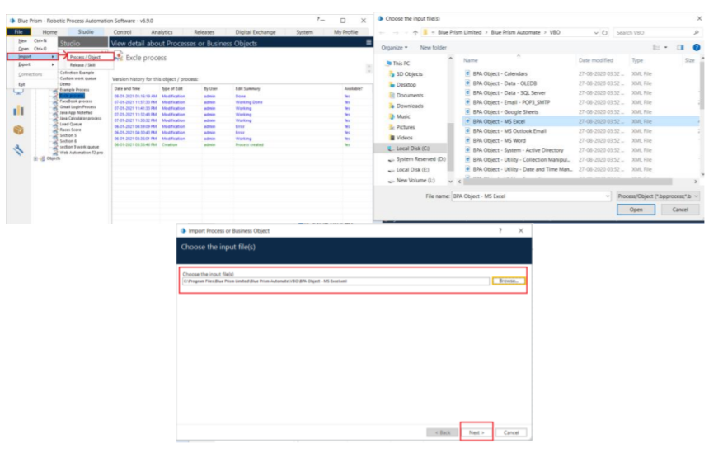

Fig 5.1

**Activity 2: Creating the Process Object from Object Studio**

Process studio has only the Main page. We can call from the process studio. We use the Process studio for developing and testing. 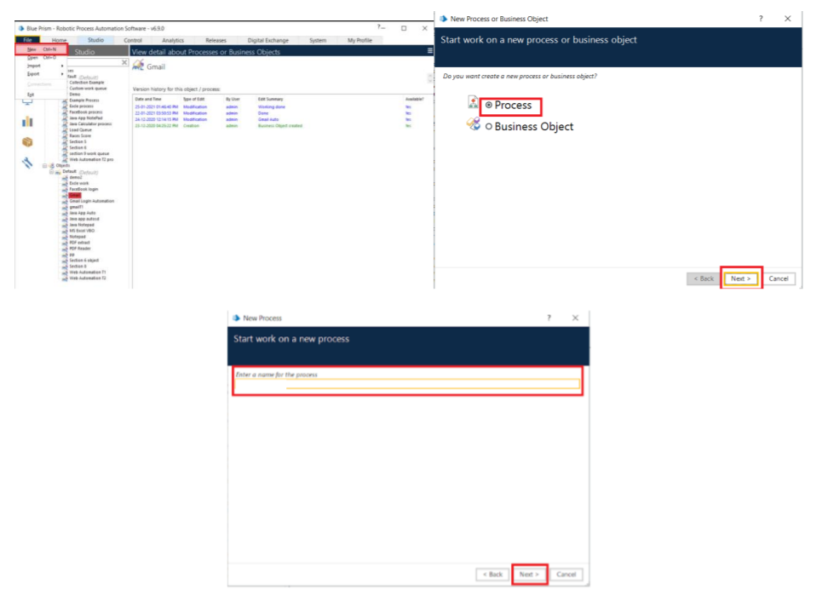

Fig 5.2

12.

**Open Created Process Model (HR Payroll Process)**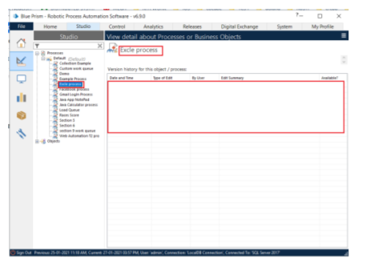

Fig 5.3

**1. Create Action Stage as “Create Instance” (Business Object = MS Excel VBO; Action = Create Instance).**

a. Click on the Outputs tab

I. Create Data Item, type = number, name = “handle”. Drag it into the store in column.

II. Click on ok.

13.

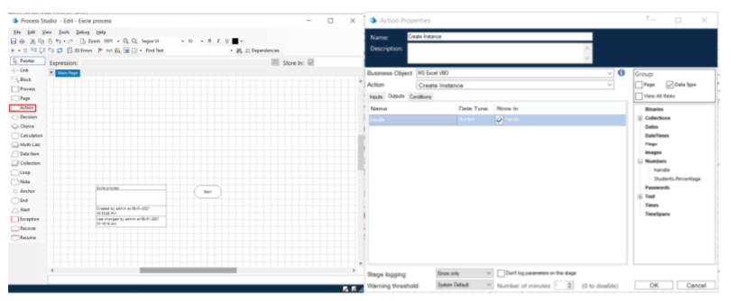

Fig 5.4

**2. Create Action Stage as “Open Excel file” (Business Object = MS Excel VBO; Action = Open Workbook).**

a. Click on the Inputs tab

i. Drag “handle” data item into handle Value column.

ii. Set file path of excel file in File Name Value column

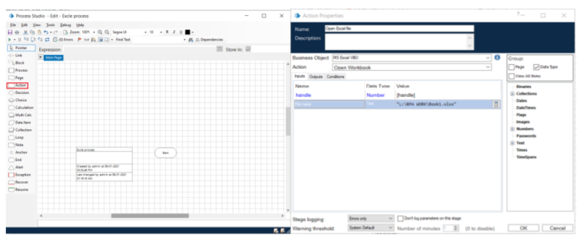

Fig 5.5

b. Click on the Outputs tab

14.

i. Create Data Item, type = Text, name = “Workbook Name”. Drag it into the Store in column. Click on OK.

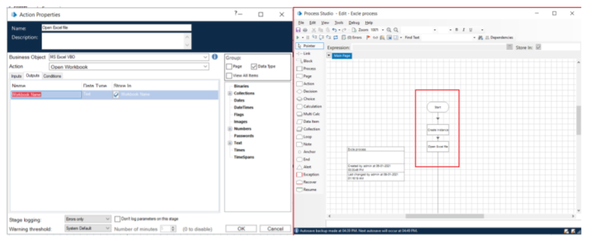

Fig 5.6

**3. Create Action as “Get to collection” (Business Object = MS Excel VBO; Action = Get Workbook As Collection).**

a. Click on the Inputs tab

i. Drag “handle” data item into handle Value column.

ii. Drag “Workbook Name” data item into the Workbook Name Value column

iii. Write Worksheet name as “Sheet1”.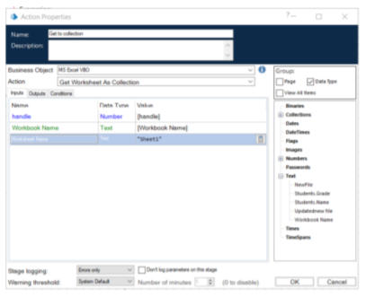

Fig 5.7

15.

b. Click on the Outputs tab

i. Create Collection as “Employee_”, with the following fields.

ii. Use Add Button to add fields in collection.

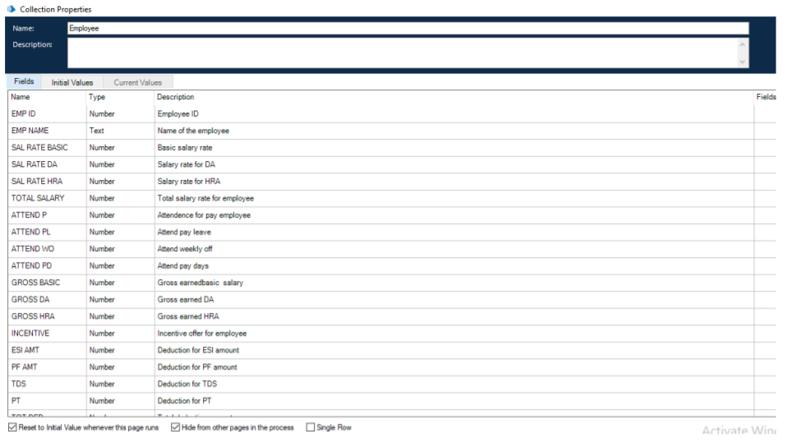

Fig 5.8

**4. Drag Loop module, Drag Multi Calculation module. Connect loop start with Multi Calc stage. Open Multi Calculation Properties and create the following fields.**

a. [Employee__.SAL RATE BASIC]*0.1

b. ([Employee__.SAL RATE BASIC+Employee__.SAL RATE DA])*0.3

c. [Employee__.SAL RATE BASIC+Employee__.SAL RATE DA+Employee__.SAL RATE HRA]

d. [Employee__.ATTEND P]+[Employee__.ATTEND PL]+[Employee__.ATTEND WO]

e. ([Employee__.SAL RATE BASIC]*[Employee__.ATTEND PD])/31

f. ([Employee__.SAL RATE DA]*[Employee__.ATTEND PD])/31

g. ([Employee_.SAL RATE HRA]*[Employee_.ATTEND PD])/3

h. [Employee_.GROSS BASIC]+ [Employee_.GROSS DA]+ [Employee_.GROSS HRA]+ [Employee_.INCENTIVE]

i. [Employee_.TOTAL GROSS]*0.0075

16.

j. ([Employee_.GROSS BASIC]+ [Employee_.GROSS DA])*0.12

k. [Employee_.ESI AMT]+[Employee_.PF AMT]+[Employee_.TDS]+[Employee_.PT]

l. [Employee_.TOTAL GROSS]-[Employee_.TOT DED]

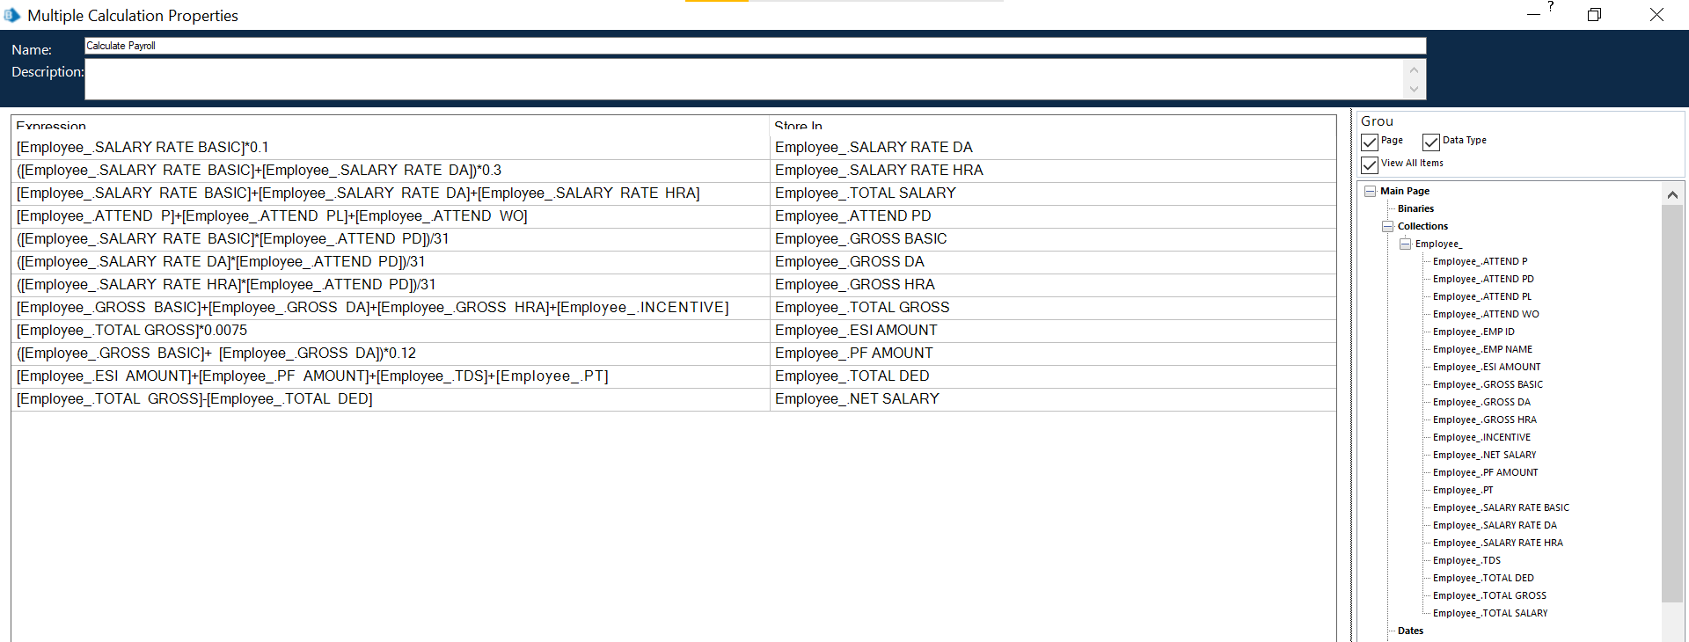

Fig 5.9

**5. Create Action Stage as “Write collection” (Business Object = MS Excel VBO; Action = Write Collection).**

a. Click on the Inputs tab

i. Drag “handle” data item into handle Value column.

ii. Drag “Workbook Name” data item into the Workbook Name Value

column.

iii. Drag “Employee” Collection into the Collection Value column.

iv. Write Worksheet name as “Sheet1”.

v. Write Cell Reference as “A1”.

vi. Set Include Column Names as True

17.

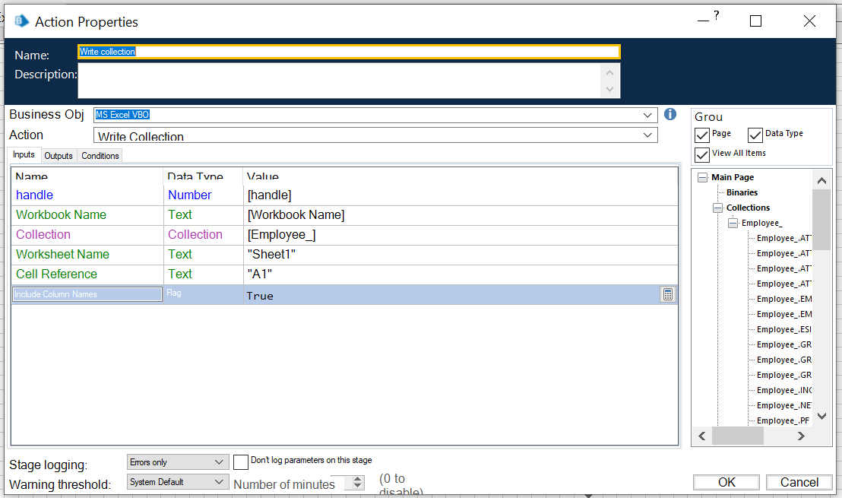

Fig 5.10

**6. Create Action Stage as “Save Excel file” (Business Object = MS Excel VBO; Action = Save Workbook).**

a. Click on the Inputs tab.

i. Drag “handle” data item into handle Value column.

ii. Drag “Workbook Name” data item into the Workbook Name Value column.

**7. Create Action Stage as “Close workbook” (Business Object = MS Excel VBO; Action = Close Current Workbook).**

a. Click on the Inputs tab

b. Drag “handle” data item into handle Value column

c. Do connections as follows.

18.

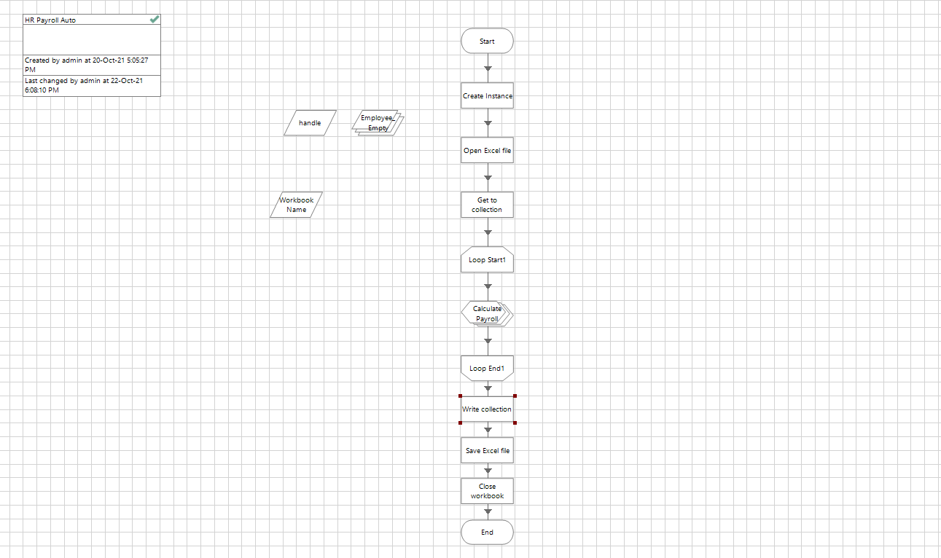

Fig 5.11

d. Input Excel file data

**Activity 3: Testing the Process Object from Object Studio**

Click on the Main Page, click on the Green play button to run the ‘Excel Process’ Process object. It shows COMPLETED when there is no error or no failure in the object.

Click on the Main Page, click on the Reset button to reset the cache for rerun the process object as fresh.

19.

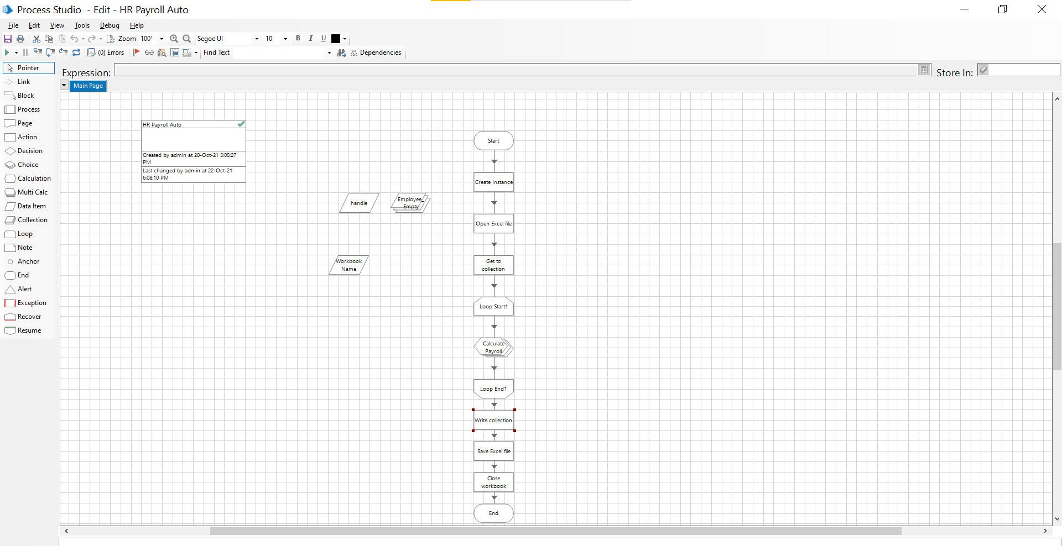

Fig 5.12

20.

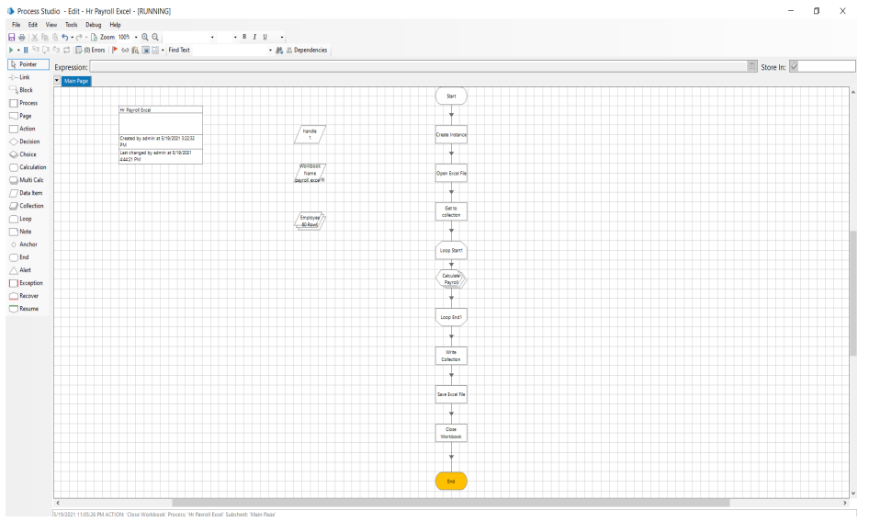

Fig 5.13

21.

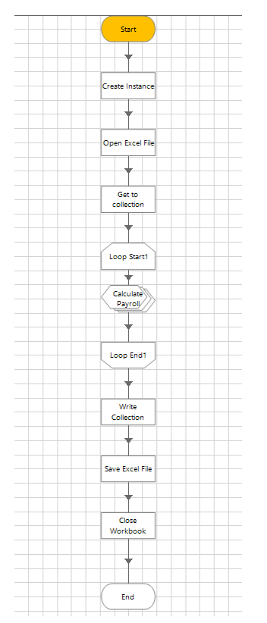

Fig 5.12.1

22.

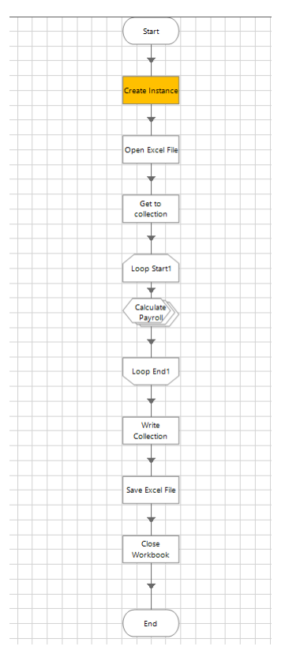

Fig 5.12.2

23.

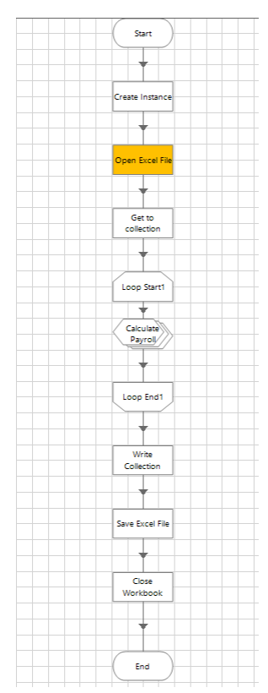

Fig 5.12.3

24.

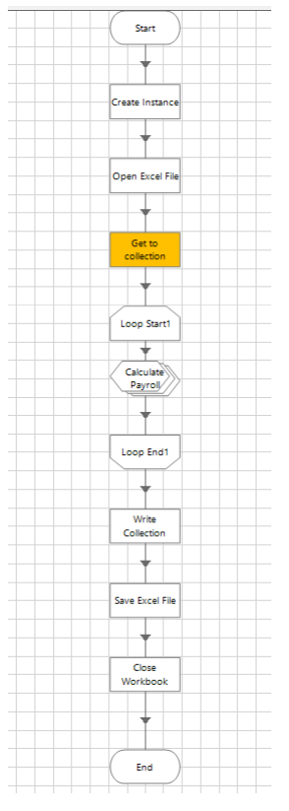

Fig 5.12.4

25.

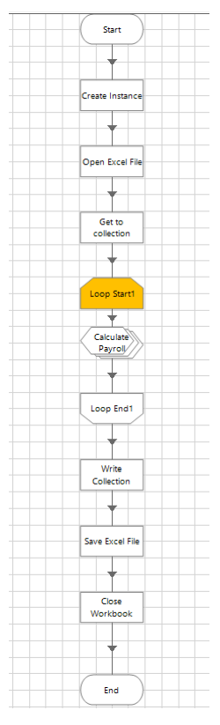

Fig 12.5.5

26.

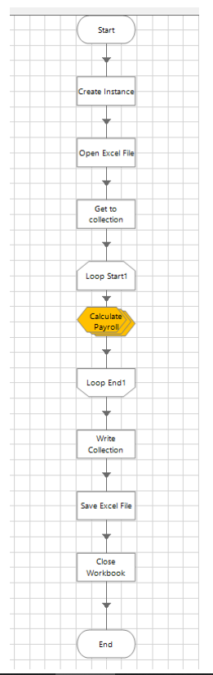

Fig 12.5.6

27.

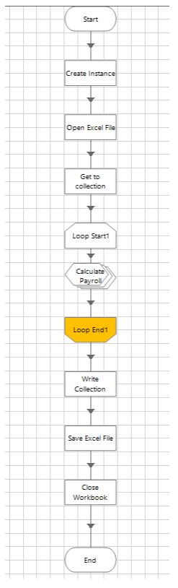

Fig 12.5.7

28.

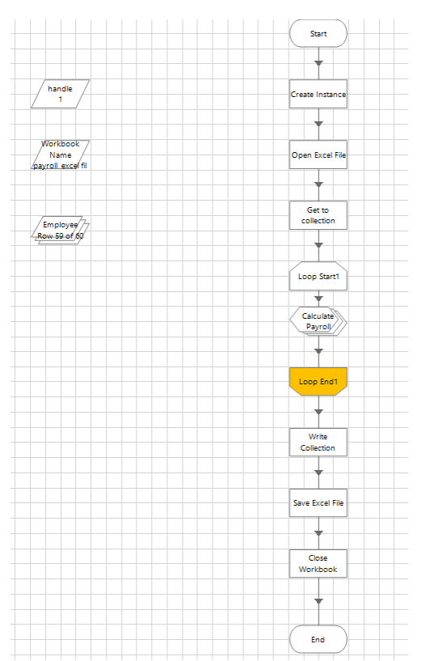

Fig 12.5.829.

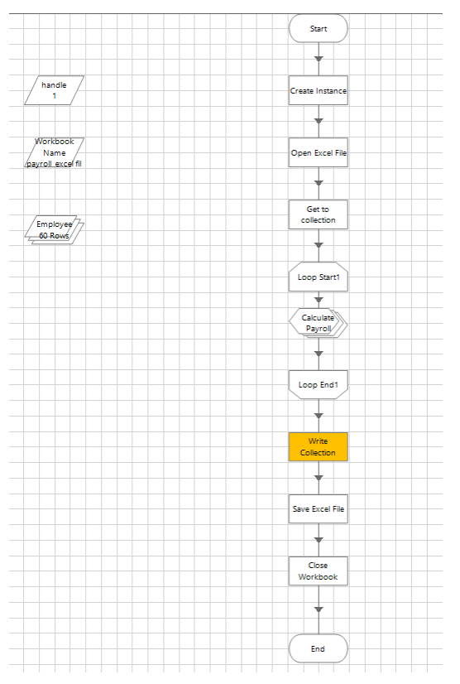

Fig 12.5.9

30.

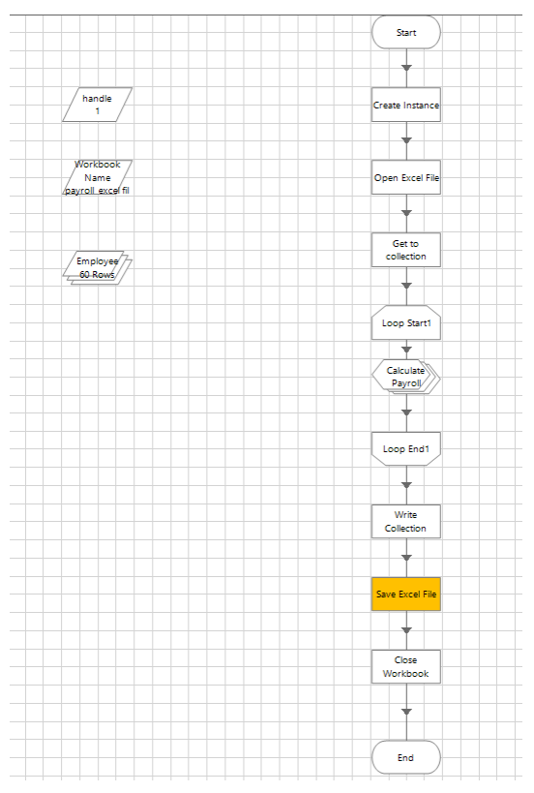

Fig 12.5.10

31.

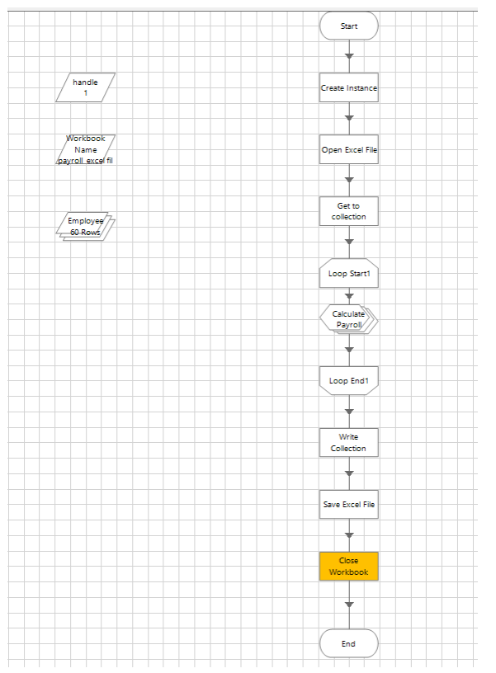

Fig 12.5.11

32.

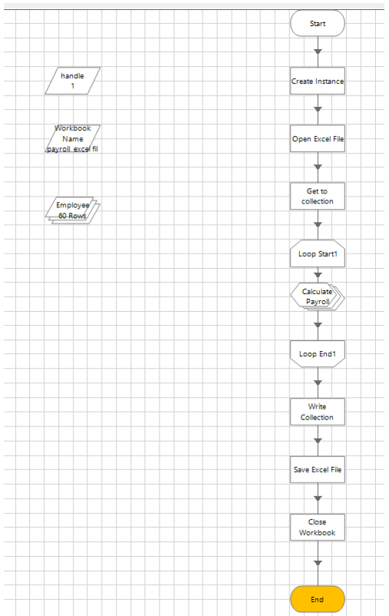

Fig 12.5.12

33.

**Output Excel file:**

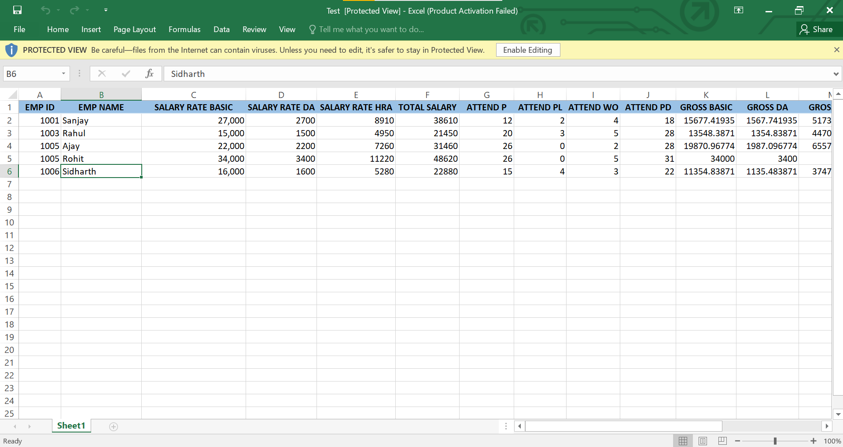

Fig 13

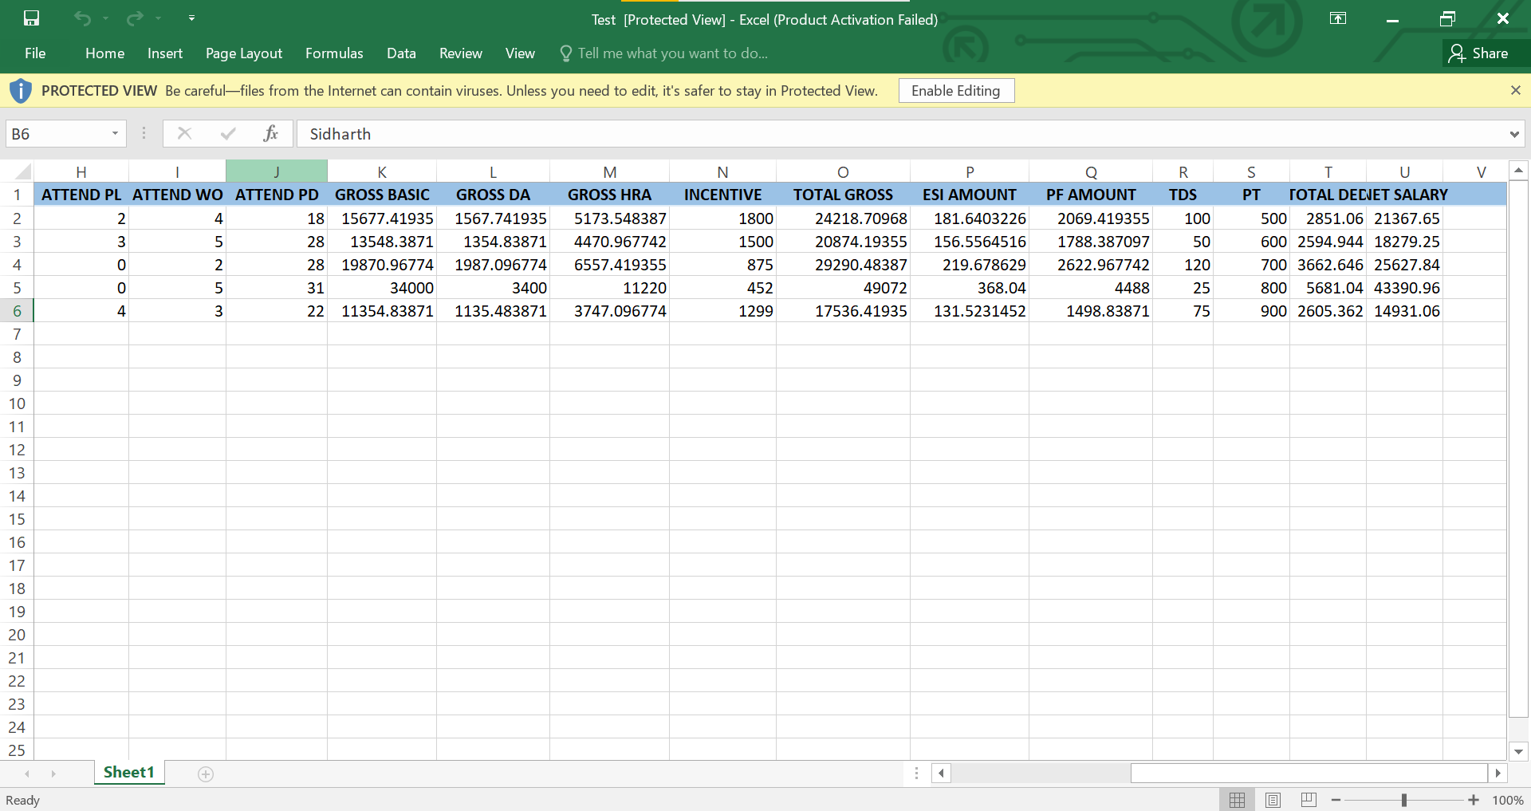

Fig 13.1

34.

**6. CONCLUSION**

The discussion of the effects of HR Automation perceived buy the employees regarding both individual as well as organizational perspective, presented in this Study is far from comprehensive. HR automation influences people, organizations, and societies in innumerable other ways. Perhaps we can identify some unique effects that Information Technology has on the way we live, learn, work, and play. Nevertheless, the variables studied in this research are sufficient to recognize that the changes caused by HR automation introduce a variety of new issues for individuals and Organizations and radically alter the importance of certain preexisting cultures and practices. Each technology is likely to affect multiple groups of people, whether directly or indirectly. Moreover, the effects of any given technology are rarely only beneficial or only detrimental; they typically create a complex web of consequences that may be both positive and negative. This study and the entire research reveal that evolution of HR process automation is not happening in a vacuum. Information technology has developed into an integral part of modern Organizations, becoming interrelated with numerous aspects of the work environment. Further advances in information technology will inevitably reverberate in the culture of individuals, as well as organizations. In the same manner, changes in the individual and organizational work pattern will create new demands that will encourage the development of new technologies. In order to understand the overall perception of the employees with respect to the benefits that an employee perceive at individual level, various tests were attempted. From the results it is clear that, employees perceive HR process automation is beneficial for an organization as well as themselves. Employees believe that HR automation will help in increase of access of information within the organization. This will further enhance the clarity of work as adequate and necessary information dissipation. They agree that there is a timely availability of information to carry on the work process due to automation. Individuals agree that HR automation has helped in the timely credit of their salary or income and hence made the whole system of salary administration simple. From the study it can be observed that employees perceive HR automation gives employees more autonomy at work. In order to understand the employee perception on the organizational benefits in HR automation within organizations, the same tests were attempted. From the results it is clear that, HR automation will increase the quality of HR delivery. It is also clear from the study that employees perceive, Automating HR processes encourages better and virtual feedback. They believe, automating HR processes will help in building the concept of egalitarianism. A sense of togetherness within the organization. This will improve relations and further enhance the organizational culture. People also perceive that HR process automation will make people more virtual. The major findings also include the fact that employees believe Automating HR processes will not delay the decision making time. Also, they disagreed to the fact that Automating HR processes does not affect employee interaction in an organization. The proposed can get detailed information about mobility of employee by

35.

organization. Multiple authorized users will be able to login and logout from a web browser. Login checks (username, password) are controlled by administrator. Administrator will have total control to completely customize the payroll system. Head of the department will be able to authenticate new employees, update existing employees pay, view reports while the operator may calculate pay and can only view reports. The system is user friendly. Whenever there is an error in entering data, it immediately shows an error.

**SCOPE:**

**Recurring Payroll Services:**

• Gross pay calculation (basic salary, wage supplements, occasional payments, cost reimbursements)

• Calculation of payroll related taxes and contributions.

• Recording and processing of garnishments and other deductions.

• Preparation of payroll slips and other outputs broken down by employees or by

cost centers for managerial and operational use.

• Data recording and processing in connection with voluntary pension and health insurance funds, reporting to the pension funds.

• Recording of wage and labor-related data (registration of personnel information, holiday and sick leave balances).

• Providing data and information for posting into the General Ledger.

• Data reports and certificates related to payroll processing (to the tax and social security authorities, the Statistical Office, etc.).

• Full range of Social Insurance management

• Tasks related to new comers and departing employees

• Annual services connected to payroll processing and social security administration

• Preparation and submission of tax declarations

• Payroll disbursement services:

36.

• Movement of all payments, calculated during the pay processing cycle (net salary, tax, social security, etc.).

• Specified data reports for the Client's accounting.

• Other services upon separate written request including:

• Cafeteria management.

• Tax advisory.

• Labor management.

• HR consultancy

**7.FUTURE ENHANCEMENTS**

This salary management program can be further enhanced by a budget program in future. In budget program every team leader will have support to manage and utilize specific amount of money in an efficient way with this amount he will manage everything like college expenditures etc. The prototype automated payroll system is complete in itself and ready to be implemented but changes and growth in requirements will be a reality on every software project so there is need to timely update them. The same applies to this payroll system. There is always room for improvement, and the software we created can also be improved. This is especially because we had to create it within a limited time. With more time, the software can be improved to include security and different types of users. This would be the first step in making the software network-enabled, and eventually web-enabled. This was our original afterthought to programming the software, and we had chosen Blue Prism. In addition, the software can also be improved in terms of the calculations it can do, and more flexibility in the rates used in calculations per employee.

37.

**8. BIBLIOGRAPHY AND REFERENCES**

1. Ball KS. The use of human resource information systems: a survey. Personnel review. 2001; 30(6):677-693.

2. Beadles II, Aston N, Lowery CM, Johns K. The impact of human resource information systems: An exploratory study in the public sector. Communications of the IIMA. 2005; 5(4):6.

3. Bell BS, Lee SW, Yeung SK. The impact of e‐ HR on professional competence in HRM: Implications for the development of HR professionals. Human Resource Management. 2006; 45(3):295-308.

4. Broderick R, Boudreau JW. Human resource management, information technology, and the competitive edge. The Executive. 1992; 6(2):7-17.

5. Fernández-Sánchez JA, de Juana-Espinosa S, Valdés Conca, j. use of HRIS in recruitment process.

https://ijmter.com/papers/volume-3/issue-2/automated-payroll-system.pdf https://aip.scitation.org/doi/pdf/10.1063/1.5055526 https://ijarcce.com/wp-content/uploads/2015/02/IJARCCE1M.pdf http://www.ijrdt.org/upload/717858- Survey%20On%20Various%20Automated%20Payroll%20System.pdf https://www.giac.org/paper/gsec/1392/automated-human-resources-payroll-hrpayroll-systemsecurity-test-plan/102607 https://silo.tips/download/software-testing-process-using-a-payroll-system-as-a-case-study https://www.slideshare.net/ShubhamModi5/payroll-management-system-srs https://relevant.software/blog/how-to-build-payroll-software-complete-guide/ https://syndeohro.com/benefits-automated-payroll/

38.